SQL Interview Assessment

# Data

The data provided is for a recurring revenue software business, and shows the contracts that they have with clients. See the field definitions below:

* Customer ID - unique customer identifier
* Contract start date – start date of contract with customer
* Contract end date – end date of contract with customer
* Contract value – total value of contract with customer, across duration of contract (i.e. from start date to end date)

# Task

The business is interested in understanding how spending from customers has changed over time. Specifically, over a rolling 12 month period they would like to allocate revenue in each month to the following categories:

* Up-sell – an increase in revenue from existing customers spending more than they did 12 months ago
* Down-sell – a decrease in revenue from existing customers spending less than they did 12 months ago
* Churn – a decrease in revenue from customers leaving (i.e. they were a customer 12 months ago, but no longer are a customer)
* New customers – an increase in revenue from new customers (i.e. those who weren’t customers 12 months ago)

In order to answer this question, the business would like to be able to view the following view of revenue for any month.

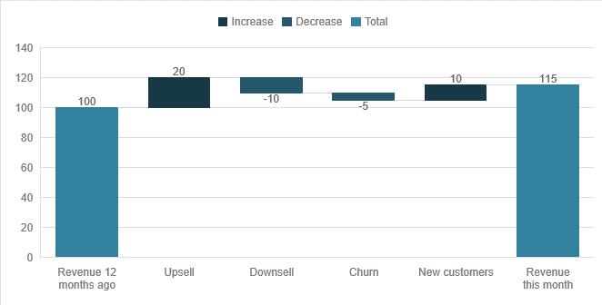

Please use the data provided to create a table that would enable you to generate this chart for any month in a BI tool like Power BI or Tableau.

# Assumptions

* You can assume the revenue generated from first month contract assumed up to month before the date the contract closes